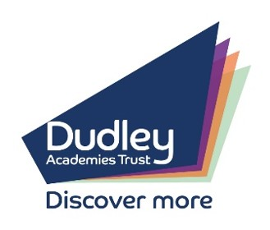
DUDLEY ACADEMIES TRUST

PRIMARY UNIFORM 2022/23

School uniform is very important, and we want the children to take a pride in themselves and to be proud of being at our school. The following uniform information is also available via the school website under Parents & Carers > Uniform & Suppliers.
Girls’ Uniform  - Dark grey skirt/dress/trousers.  - Dark grey salvar and kameez.  - White blouse/polo shirt.  - Royal blue sweatshirt/cardigan (waist length, no hood).  - White, black or grey socks/tights.  - Royal blue headscarf (no longer than shoulder length).  - Summer: Blue and white gingham dress (optional).  - Summer: White leggings/tights (optional). | Boys’ Uniform  - Dark grey trousers.  - White shirt/polo shirt.  - Royal blue sweatshirt/jumper.  - White, black or grey socks.  - Summer: Dark grey shorts (optional).
Boys & Girls PE Kit  - Black shorts/jogging bottoms.  - Plain royal blue polo shirt.  - Black pumps.  - Black trainers for outdoor PE. | Boys & Girls Shoes  - Plain, flat black shoes. No heels/platforms. Must cover toes and be secured to the foot.

Notes
- All items of clothing must be plain, i.e., with no embellishment, patterns or branding. The only exception is the school logo.
- No jewellery or personal items are allowed to be worn apart from stud earrings and a watch. For safety, such items MUST be removed for PE.
- No make-up, including nail varnish, is allowed.
- Please note children do not need large bags (no bigger than a book bag). Storage is limited, so please only send what is necessary.
- For health and safety reasons all footwear should be flat. No heels or platforms are allowed and all footwear must cover toes and be secured to the foot.
- Items of uniform can be purchased from Crested Schoolwear, however please speak to us in school if families experience any barriers in obtaining uniform.
- It is expected that logoed jumpers are worn to school by all pupils, however plain polo shirts and PE kits are acceptable.

